623 Club
Behaviour Management Policy
623 Club uses effective behaviour management strategies to promote the welfare and enjoyment of children attending the Club. Working in partnership with parents, we aim to manage behaviour using clear, consistent and positive strategies, and with adults modelling positive behaviour. The Club rules are clearly displayed at every session and are discussed regularly.

Whilst at 623 Club we expect children and Parents/ carers to:
- Use socially acceptable behaviour
- Comply with our Policies.
- Comply with the Club rules, which are compiled by the children attending the club
- Respect one another, accepting differences of race, gender, ability, age and religion
- Develop their independence by maintaining self-discipline
- Choose and participate in a variety of activities
- Ask for help if needed
- Discuss issues so we can work together to resolve them.
- Enjoy their time at the Club.

Encouraging positive behaviour
At 623 Club positive behaviour is encouraged by:
- Staff acting as positive role models
- Praising appropriate behaviour
- Sticker rewards
- Informing parents about individual achievements
- Offering a variety of play opportunities to meet the needs of children attending the Club.

It is inevitable that as children develop and learn, there are times when they need support and guidance to understand that their behaviour is not acceptable. Staff at the Club will try to determine the cause or triggers of the inappropriate behaviour to prevent the situation from recurring.

Dealing with inappropriate behaviour
- Challenging behaviour will be addressed in a calm, firm and positive manner.
- In the first instance, the child will be temporarily removed from the activity. Discuss with the chair if a Parent is behaving inappropriately.
- Staff will discuss why the behaviour displayed is deemed inappropriate.
- Staff will give the child an opportunity to explain their behaviour, to help prevent a recurrence.
- Staff will encourage and facilitate mediation between children to try to resolve conflicts through discussion and negotiation.
- If the inappropriate behaviour appears to be as a result of boredom, staff will consult with the child to find activities that more fully engage them.
- Staff will consult with parents to formulate clear strategies for dealing with persistent inappropriate behaviour.
- No staff member will ever threaten any punishment that could adversely affect a child’s well-being (eg withdrawal of food or drink).
- Record any incident/ near miss.
If after consultation with parents and the implementation of behaviour management strategies, a child or parent continues to display inappropriate behaviour, the Club may decide to exclude the Parent and Child.
The reasons and processes involved will be clearly explained to the child.

Physical intervention
Physical intervention will only be used as a last resort, when staff believe that action is necessary to prevent injury to the child or others, or to prevent significant damage to equipment or property. The manager will be notified, and an Incident record will be completed. The incident will be discussed with the parent or carer as soon as possible.

If staff are not confident about their ability to contain a situation, they should call the manager or the parent, in extreme cases, police.

All serious incidents will be recorded on an Incident record and kept in the child’s file. This may be used to build a pattern of behaviour, which may indicate an underlying cause. If a pattern of incidents indicates possible abuse, we will implement child protection procedures in accordance with our Safeguarding policy.

Corporal punishment
Corporal punishment or the threat of corporal punishment will never be used at the Club.

We will take all reasonable steps to ensure that no child who attends our Club receives corporal punishment from any person who cares for or is in regular contact with the child, or from any other person on our premises.

Related policies
See also: Equalities policy, Aggressive behaviour policy, Complaints policy, Safeguarding policy.

This policy was adopted by: Emma Collins | Date:31/3/26
To be reviewed: 31/3/27 | Signed: 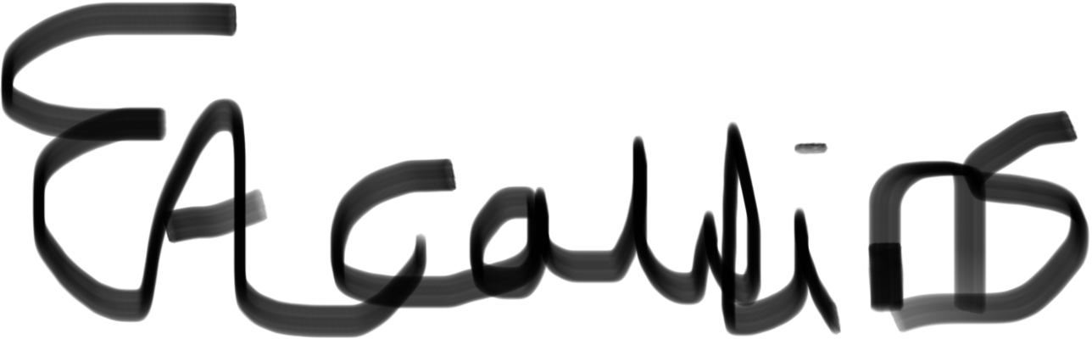
Reviewed on:

Written in accordance with the Statutory Framework for the Early Years Foundation Stage (2021): Safeguarding and Welfare Requirements: Managing children’s behaviour [3.53 – 3.54].

