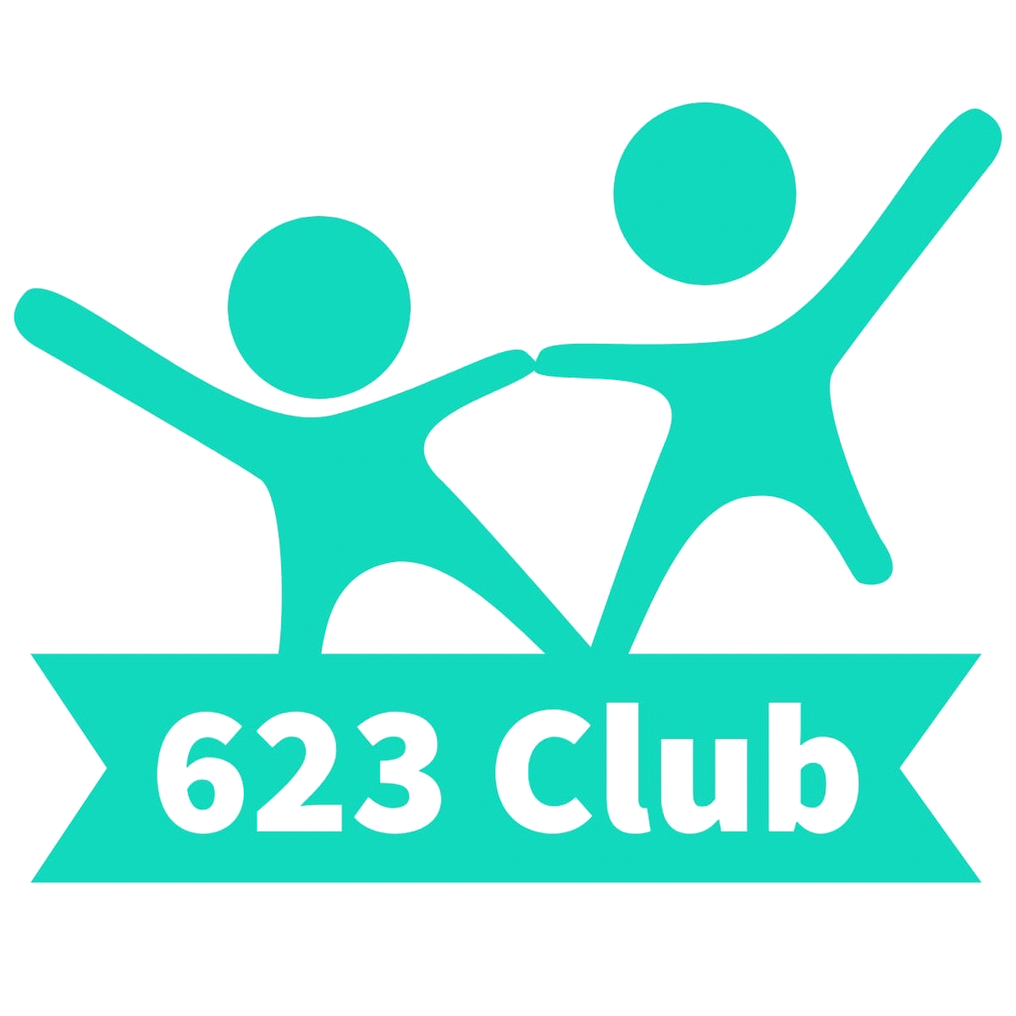

Parents’ Handbook

About The Club
623 Club is a registered Charity that is regulated by Ofsted and licensed by the Food Standards Agency (Ofsted No 2784837 and Charity No 1204275). 623 Club high quality wrap around care based in Calver, for children aged 3.5 - 11 years. The Club consists of a management committee, Chair, two Co Secretaries and a treasurer plus parent committee members.
We then have a Manager and Play-workers who work directly with the children.

The Club is open from 7:30am till 9am Monday- Friday and 3.00pm until 6.00pm Monday- Friday, during term time.

We are Ofsted registered and payments can be made through tax-free childcare.

We are based at the Scout Hut. We have outside space on the premises and we also have access to the MUGA at Curbar School.

Aims
At Out of School Club we aim to provide a safe and secure and relaxed environment, offering a range of activities to reflect the interests of the children in our care.

What we offer
Our Club follows the Play work Principles, so the children are free to choose activities and resources as they wish. There is a activity schedule with planned activities but children can also choose from a variation of activities, craft, board games, construction, computer games, physical play, cookery, and reading.
During Holidays club sessions there are lots of planned activities such as, baking, local walks, Den building and orienteering. Staff will plan these activities in the lead up to the holiday club. Children are also welcome to choose freely from our equipment.

What we provide
We provide healthy light tea including fresh fruit and vegetables. We promote independence, by encouraging the children to prepare some foods themselves, and to clear away after themselves. We use fresh ingredients and follow statutory guidelines. Fresh drinking water is available at all times. We meet individual dietary requirements and parental preferences wherever possible. We recognise the importance of healthy nutrition for children delivered in a calm, friendly setting. We allow children to decide if they want to eat, but will encourage them to eat a balance of foods and request that food be consumed whilst sitting at the food tables.

Club Staff

Manager- Emma Collins - Level 3 in Childcare and Education, Safeguarding, First aid, Food Hygiene, Being a key person, Additional needs, Outdoor play, Understanding and Addressing behaviour, Data Protection and GDPR, Designated Safeguarding lead, Online Safety,

Playworkers:

Alla- is a qualified teacher from Ukraine. Safeguarding, Prevent, first aid and food hygiene.

Emily - Level 3 in Childcare, Prevent training, food hygiene, first aid

Kelli- Level 2 in developing skills for teaching and learning in schools, Prevent, Safeguarding, food hygiene, first aid

Georgia- Level 3 apprentice, safeguarding training , Food hygiene and Prevent training and first aid

Ava- In the process of teacher training, Safeguarding and First aid

Kaylee- Level 3 student, safeguarding training, Food hygiene and Prevent training

Ella and Matilda – Students with lots of sports and babysitting experience

Our aim is to provide a smooth transition between school and club.
All of our staff have significant experience of working with children and undertake professional development training. All staff members have appropriate DBS checks.

If you have a query or concern at any time, please speak to a member of staff at the club when you collect your child. If you prefer to arrange a more convenient time for a meeting please contact us on the email address or phone number provided.

Organisation

623 Club is a charity that is regulated by Ofsted and licensed by the Food Standard Agency. The club is run by a team of staff and a committee. We have a chair, Secretary, Treasure and other committee members. We enjoy a close working relationship with Curbar, Baslow and Pilsley Schools in order to ensure continuity of care, and to maintain good communication links.

Policies and procedures
The Club has clearly defined policies and procedures. Key points of the main policies are included in this Handbook. Copies of the full policies are kept at the Club and are available for parents to consult at all times.
TERMS AND CONDITIONS

Admission
Our Club aims to be accessible to children and families from all sections of our local community. Admission to the club is organised by the Manager and we use a waiting list system when the need arises. The waiting list will be operated on a first come-first served basis, with the exception of siblings who will have priority for the same days as a sibling already attending.
We require a completed set of registration forms for your child before they can attend the club. This information will be treated as confidential and will be stored appropriately.

Payment of fees

Fees are charged at: Breakfast club £9, siblings £8 per session
After school club £12, siblings £11.00 per session.
Transport to feeder schools from breakfast club £1.
Transport from feeder schools £2.
Holiday club:
8:30am-4:30pm £38.50 early bird up to two weeks before £34.50
4:30am-6pm extra £5.50
Fees can be paid using Tax-Free Childcare or childcare vouchers
The price per session per child applies to all children. This is payable for all booked sessions including when your child is sick, or on holiday (regardless of the amount of notice given).
We do not charge for bank holidays.
Invoices are send out each half term. Please ensure that fees are paid within 14days.
If you are having difficulty paying fees, please speak in confidence to the Manager.

Changes to days and cancelling your place
You must give us one month’s notice of termination, or of changes in attendance. If you need to change the days that your child attends, please contact the Manager. We try to accommodate such changes wherever possible. Ad hoc bookings are available if possible due to space. Please email sixtwothreeclub@yahoo.co.uk
For holiday club sessions 14 days notice is required.

Temporary changes
Please remember that we need to know if your child will not be attending the Club for any reason. Even if you have informed your child's school, you still need to notify us as the school does not automatically pass this information on to us. If your child doesn’t attend a booked session, we will have to treat them as a ‘missing child’ unless you have notified us of their absence.
If you know in advance of any days when your child will not be attending during the following week, please try to let the Manager know. In cases of illness or emergency when notice cannot be given, please call as soon as you can. Contact details can be found at the end of this Handbook.

Induction
You and your child are welcome to visit the Club before your child's first day, to familiarise yourselves with the setting and to help your child settle in.
During your child’s first session time will be set aside for an induction. The induction will include running through Club's rules and routines (including meal times, collection, children's meetings), and introducing your child to the staff and other children.

Arrivals and departure
Our staff or the Community Transport bus collect children from Curbar, Baslow and Pilsley School. A register is taken when children arrive in our care, and we ask that you sign out your child each day when you collect them.
Please ring the door bell and a member of staff will bring your child out. We expect that your child will normally be collected by the people you have named on the registration form. If you need a different person to collect your child on a particular day, you must notify us in advance. We will not release your child into the care of a person unknown to us without your authorisation. A password system may be used.

The club finishes at 6.00pm, if you are delayed for any reason please telephone the Club to let us know. A late payment fee of £5 per 15minutes will be charged if you collect your child after the Club has closed.
If your child remains uncollected after 6.30pm [30 minutes after your club closes] and you have not warned us that you will be delayed, and we have been unable to reach you or any of your emergency contacts, we will follow our Uncollected Children Policy and contact the Social Care team.

Holiday Club
Children will be provided with a morning snack. They will need a packed lunch, water bottle, coat/hat and change of clothes. Please be aware some of the activities can be messy. A activity schedule will be send out before your child is due to be at holiday club.

Child protection
We are committed to building a ‘culture of safety’ in which the children in our care are protected from abuse and harm. Any suspicion of abuse is promptly and appropriately responded to. We comply with local and national child protection procedures and ensure that all staff are appropriately trained. We ask that parents and carers don’t use their mobile phones whilst in the club. For more details see our Safeguarding Policy.

Equal opportunities
Our Club provides a safe and caring environment, free from discrimination, for everyone in our community including children with additional needs.
- We respect the different racial origins, religions, cultures and languages in a multi- ethnic society so that each child is valued as an individual without racial or gender stereotyping.
- We will challenge inappropriate attitudes and practices.
- We will not tolerate any form of racial harassment.

Special needs
We make every effort to accommodate and welcome any child with special needs. We will work in liaison with parents or carers and relevant professionals to fully understand your child’s specific requirements. We will endeavour to accommodate all children of all abilities, whilst working within the Club’s limitations. Each case will be considered individually and risk-assessed to ensure everyone’s safety.
For more details on equal opportunities and special needs, see our Equalities Policy.

GENERAL INFORMATION

Behaviour (children)
Children and staff have created rules for acceptable behaviour whilst at the Club. These are displayed at the Club for everyone to see.
We have a clear Behaviour Management Policy.
The Club promotes an atmosphere of care, consideration and respect for everyone attending: children, staff and visitors.
We encourage appropriate behaviour through: praise for good behaviour; emphasis on co- operative play and sharing; talking to children with the courtesy that we expect from them and engaging children in activities
The Club has procedures for dealing with unacceptable behaviour. We recognise that poor behaviour can occur from time to time for reasons that are not always evident, or as a result of special needs. We will try to be flexible in order to accommodate such cases.
However, if your child is violent, or if their behaviour poses an immediate danger to themselves or others, we will require you to collect them from the Club immediately. In exceptional circumstances, and only when all other attempts at behaviour management have failed, we reserve the right to permanently exclude a child from the Club.

Behaviour (adults)
We will not tolerate from any person, whether a parent, carer or visitor: bullying; aggressive, confrontational or threatening behaviour; or behaviour intended to result in conflict. Our Club is a place of safety and security for the children who attend and the staff who work here, and we reserve the right to ban anyone exhibiting inappropriate behaviour from our premises. See our Aggressive Behaviour Policy for more details.

Illness
We are unable to care for children who are unwell. If your child becomes unwell whilst at the Club we will contact you and ask you to make arrangements for them to be collected.
Please inform the Manager of any infectious illness your child contracts. If your child has had sickness or diarrhoea please do not send him or her to the Club for 48 hours after the illness has ceased. See our Illness and Accidents Policy for more details.

Accidents and first aid
Every precaution is taken to ensure the safety of the children at all times, and the Club is fully insured. We have staff who are trained in first aid and a first aid kit is kept on the premises. If your child has an accident whilst in our care, you will be informed when you collect your child. For full details see our Illness and Accidents Policy.
Medication
Please let the Manager know if your child is taking prescribed medicine. If your child needs to take medicine whilst at the Club you will need to complete a Permission to administer medication form in advance. See our Administering Medication Policy for more details.

Complaints procedure
If you have any queries, comments or need to discuss any matters concerning your child, please feel free to speak the Manager or Chair.
Verbal complaints will be brought to the next staff meeting for discussion and action.
All written complaints will be acknowledged within five working days of receipt and a full written response will be given within 28 days.
A full copy of our Complaints Policy is available on request.

Privacy Notice

At 623 Club we respect the privacy of the children attending the Club and the privacy of their parents or carers. The personal information that we collect about you and your child is used only to provide appropriate care for them, maintain our service to you, and communicate with you effectively. Our legal basis for processing the personal information relating to you and your child is so that we can fulfil our contract with you.

Any information that you provide is kept secure. Data that is no longer required* is erased after your child has ceased attending our Club.

We will use the contact details you give us to contact you via phone, email and post so that we can send you information about your child, our Club and other relevant news, and also so that we can communicate with you regarding payment of our fees.

We will only share personal information about you or your child with another organisation if we:
- have a safeguarding concern about your child
- are required to by government bodies or law enforcement agencies
- engage a supplier to process data on our behalf (eg to take online bookings, or to issue invoices)
- have obtained your prior permission.

You have the right to ask to see the data that we have about yourself or your child, and to ask for any errors to be corrected. We will respond to all such requests within one month. You can also ask for the data to be deleted, but note that:
- we will not be able to continue to care for your child if we do not have sufficient information about them
- even after your child has left our care, we have a statutory duty to retain some types of data for specific periods of time* so can’t delete everything immediately.

If you have a complaint about how we have kept your information secure, or how we have responded to a request to access, update or erase your data, you can refer us to the Information Commissioner’s Office (ICO).

* We do need to retain certain types of data (such as records of complaints, accidents, and attendance) for set periods of time after your child ceases to be in our care, but we delete as much personal data as we can as soon as possible.

PLEDGE TO PARENTS
We value our relationship with parents/carers and are committed to working in partnership with you to provide top quality play and care for your children. We will:
- Welcome you at all times to discuss our work, have a chat or take part in our activities.
- Keep you informed of opening times, fees and charges, programmes of activities, menus, and procedures.
- Be consistent and reliable to enable you to plan with confidence and peace of mind.
- Share and discuss your child's achievements, experiences, progress, and friendships.
- Be available to discuss decisions about running the club.
- Ask your permission for outings and special events.
- Listen to your views and concerns to ensure that we continue to meet your needs.

CONTACT INFORMATION

Club mobile number: 07462 986690

Email Address: sixtwothreeclub@yahoo.co.uk
Ofsted Registration No: EY2653898
Website: http://www.sixtwothree.co.uk

Address: The scout Hut, Dukes Drive, Curbar, Hope valley, Derbyshire S32 3YF
Committee contact: vmcommittee623@yahoo.com
Chair- Richard Hopkins email: hopkins2231@gmail.com

Ofsted
Piccadilly Gate Store Street Manchester
M1 2WD
Tel: 0300 123 1231

