623 Club
Food Safety Policy

623 Club is committed to ensuring that safe and healthy practices around the storage, preparation and service of food are followed at all times. Staff involved in food handling and preparation have to meet high standards of personal hygiene. Any member of staff showing signs of infection or ill health will not be permitted to handle food.
623 Club follows the guidelines set out in ‘Safer Food, Better Business’ (FSA) and is registered as a food business with our local authority. We are regularly inspected by Environmental Health to ensure that health and hygiene standards are being met.
All staff involved in food handling have received food handling and hygiene training. When preparing food, staff follow the requirements of current food hygiene legislation, including:
- Always washing hands with anti-bacterial soap and hot water before and after handling food and using the toilet
- Children only eat at tables without craft/painting table cloths.
- Using clean and the correct colour coded chopping boards and cloths.
- Not being involved in food preparation if they are unwell
- Making sure all fruit and vegetables are washed before being served
- Removing jewellery, watches and bracelets, before preparing food or wearing gloves.
- Covering spots or sores on the hands and arms with a waterproof dressing
- Keeping fingernails short and clean.
- Record what is served and how we have ensured this has been done to meet the requirements.
- Staff must prepare food in a way to prevent choking.
- Staff must prepare food in line with allergies, intolerances and special dietary requirements of children attending.

Supervision whilst eating

Whilst children are eating there must always be a member of staff in the room with valid paediatric first aid certificate.

Children must always be seated and within sight and hearing of a member of staff whilst eating.

623 Club recongnises that choking can be completely silent, therefore visual supervision of children’s faces whilst eating is part of our everyday practice. Staff will remain vigilant that children are eating in a way that prevents choking and are ready to react to allergic reactions.

Allergies and dietary requirements

Before a child is admitted to the setting 623 Club will obtain information about any special dietary requirements, preferences, food allergies and intolerances that the child has. This information is stored in the filing cabinet also on an sheet in the kitchen and is shared with all staff preparing and handling food.

At each meal time 623 Club must nominate an individual who is responsible for checking that the food being provided meets the requirements for each child. This will mainly be the member of staff on snack and will be communicated at these times.

623 Club have ongoing discussions with parents and or carers and where appropriate health professionals to develop allergy action plans when needed. This information must be kept up to date.

623 Club communicates allergen information to parents through menus displayed and available on the website and conversations with parents or carers.

Staff training and allergen awareness

623 Club ensures that all staff are aware of the symptoms and treatments for allergies and anaphylaxis, the differences between allergies and intolerances and that children can develop allergies at any time. We do this through training and staff meetings.

Incident recording

When a child experiences a choking incident that require intervention, 623 Club staff must record details of where and how the child choked and make parents and or carers aware.

623 Club will review records periodically to identify if there are trends or common features of incidents that could be addressed to reduce the risk of choking. Appropriate action will be taken to address any identified concerns during this review process and following any incidents of concerns during the provision of food within our club.

Food storage
All foods are stored according to safe food handling practices and at a correct temperature, to prevent the growth of food poisoning organisms and to ensure that food quality is maintained.
Fridge temperatures are checked and recorded on a daily basis as part of our daily environment checks. If there are temperature fluctuations that are not explained by simple user error (eg failure to close the fridge properly), a new fridge will be purchased. The food would be disposed of.

Cleaning
- The fridge is cleaned thoroughly, with warm, soapy water, on a weekly basis.
- Food is checked for freshness – anything past the use by date will be disposed of.
- Freezers are defrosted and cleaned once a term.
- All food preparation surfaces are wiped clean after use with anti-bacterial cleaner and disposable cloths.
- All chopping boards are cleaned after use with warm soapy water and then thoroughly rinsed.
- Appropriate controls are implemented to reduce the risk of cross contamination.

Food diary

All food served, fridge and freezer temperatures, cleaning and actions will be recorded in the food diary by the member of staff preparing the food at each session. Food will be stored and cooked to the manufactures instructions. Staff will also look for colour change. All fruit will be washed.
Any damaged or faulty equipment should be reported the manager.

This policy was adopted by: Emma Collins | Date:31/3/26
To be reviewed: 31/3/27 | Signed: 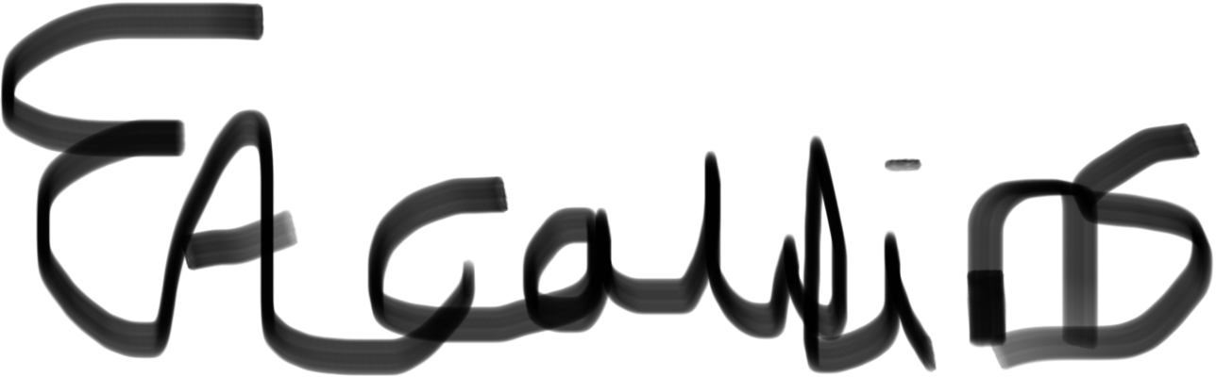
Reviewed on:

Written in accordance with the Statutory Framework for the Early Years Foundation Stage (2021): Safeguarding and Welfare Requirements: Food and drink [3.48 - 3.50].

