Health and Safety Policy
623 Club considers health and safety to be of utmost importance. We comply with The Health and Safety at Work Act 1974 and the Workplace (Health, Safety and Welfare) Regulations 1992 at all times.
The Club has appropriate insurance cover, including employer’s liability insurance and public liability insurance.
Each member of staff follows the Club’s Health and Safety policy and is responsible for:
- Maintaining a safe environment
- Taking reasonable care for the health and safety of themselves and others attending the Club
- Reporting all accidents and incidents which have caused injury or damage or may do so in the future
- Undertaking relevant health and safety training when required to do so by the manager.
Any member of staff who disregards safety instructions or recognised safe practices will be subject to disciplinary procedures.

Responsibilities of the manager
The registered person for the setting holds ultimate responsibility and liability for the safe operation of the Club. The registered person will ensure that:

- A copy of the current Health and Safety At work poster is displayed (poster is available here: http://www.hse.gov.uk/pubns/books/lawposter.htm )
- All staff receive information on health and safety matters.
- The Health and Safety policy and procedures are reviewed regularly
- Staff understand and follow health and safety procedures
- Resources are provided to meet the Club’s health and safety responsibilities
- All accidents, incidents and dangerous occurrences are properly reported and recorded. This includes informing Ofsted, child protection agencies and the Health and Safety Executive under RIDDOR (Reporting of Injuries, Diseases and Dangerous Occurrences Regulations 1995) where appropriate.
- All reported accidents, incidents and dangerous occurrences are reviewed, so that preventative measures can be taken.
- The premises are used by and solely available to the Club during opening hours
- Chemicals and cleaning materials are stored appropriately, and in accordance with COSHH data sheets.

All staff should ensure that,
- Premises are clean, well lit, adequately ventilated and maintained at an appropriate temperature
- All the Club’s equipment is safely and securely stored
- Children are not allowed in the kitchen.
- A working and charged telephone is available on the premises at all times
- If external pathways are cleared in severe weather they must be gritted too
- Daily environment checks are carried out in accordance with our Risk Assessment policy removing any hazards or reporting them to the Manager.
- Chairs should not be stacked higher than 6 high.
- COSHH items are locked away in the COSHH cupboard

Security
During Club sessions the yale is on. Staff monitor the entrances and exits to the premises throughout the session.
All gates are kept locked when outside. Door bell on the gate when gates are locked.
Staff record how many children are inside and how many outside.
All visitors to the Club must sign the Visitor Log and give the reason for their visit. Visitors will never be left alone with the children.
A register is taken and all children must be signed by staff or authorised person to say who has collected them.
Parents collect children from the door, if necessary one parent at a time can come into club.
Regular head counts are taken.
Security procedures will be regularly reviewed by the manager, in consultation with staff, parents and committee.

Toys and equipment
All furniture, toys and equipment are kept clean, well maintained and in good repair. We select toys, equipment and resources with care, and we carry out risk assessments. Broken toys and equipment are disposed of promptly.
We ensure that any flammable equipment is stored safely.

Food and personal hygiene
Staff at 623 Club maintain high standards of personal hygiene, and take all practicable steps to prevent and control the spread of infection.

- A generally clean environment is maintained at all times.
- Different colour cloths for different areas.
- Different mops for the toilet and kitchen area.
- Toilets are cleaned daily and soap and hand drying facilities are always available.
- Staff are trained in food hygiene and follow appropriate guidelines.
- Waste is disposed of safely and all bins are kept with lids closed.
- Staff ensure that children wash their hands before handling food or drink and after using the toilet.
- Cuts and abrasions (whether on children or staff) where appropriate are kept covered.
- Staff have food hygiene training.

Dealing with body fluids
Spillages of blood, vomit, urine and faeces will be cleaned up immediately in accordance with our Intimate Care policy.

Staffing levels
Staff ratios and levels of supervision are always appropriate to the number, ages and abilities of the children present, and to the risks associated with the activities being undertaken.

Related policies
See also our related policies: Illness and Accidents, Emergency Evacuation, Healthy Eating, Safeguarding, Administering Medication, Risk Assessment, Manual Handling, Fire Safety, and Intimate Care, Visitor.

This policy was adopted by: Emma Collins | Date:31/3/26
To be reviewed: 31/3/27 | Signed: 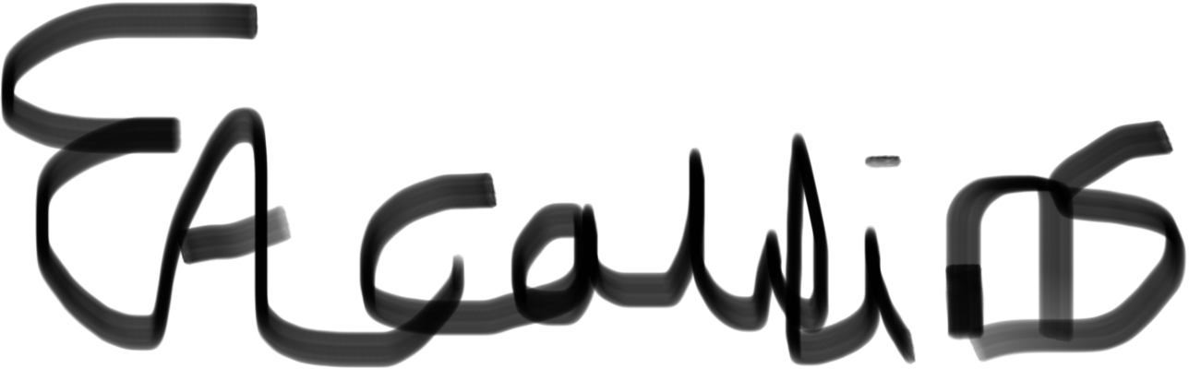
Reviewed on:

Written in accordance with the Statutory Framework for the Early Years Foundation Stage (2021): Safeguarding and Welfare Requirements: Safety and suitability of premises, environment and equipment [3.55-3.65].

