623 Club
Healthy Eating Policy

623 Club provides healthy, nutritious and balanced food and drinks. Food and drink are safely prepared with regard to the dietary and religious requirements of the children in our care. We ask parents to notify us regarding any special dietary requirements or allergies when they register their child.
Information regarding food allergies is recorded on the Allergy/ Dietary Information sheet which is in the kitchen for staff whilst food is being prepared.
We will promote healthy eating and lead by example. We have a 4 weekly menu of a variety of light tea meals to support a healthy balance diet. Staff responsible for food preparation, handling and storage have received appropriate training.

- We provide suitable healthy light tea for all the children.
- Children are encouraged to develop good eating skills and table manners.
- All children are given plenty of time to eat.
- Where appropriate, children are involved in planning and preparing food and snacks including opportunities to bake.
- Menus are changed in October and April. They are on display in the club and on the website
- Fresh drinking water is available and accessible to children at all times.
- Fresh fruit is available at all sessions.
- Withholding food is never used as a form of punishment.
- Staff discuss with children the importance of a balanced diet where appropriate.
- The Club does not regularly provide sweets for children.
- We limit access to fatty or sugary foods.
- Children are encouraged to try foods but are never forced to eat or drink anything against their will.

This policy was adopted by: Emma Collins | Date:31/3/26
To be reviewed: 31/3/27 | Signed: 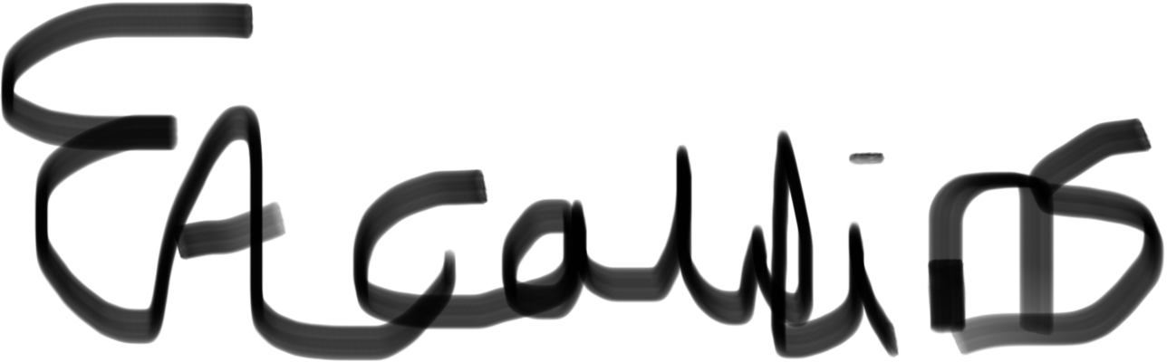
Reviewed on:

Written in accordance with the Statutory Framework for the Early Years Foundation Stage (2021): Safeguarding and Welfare Requirements: Food and drink [3.48-3.50]

