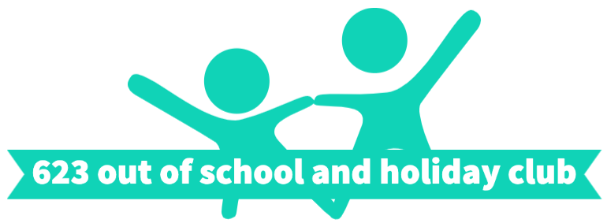

Thursday 23rd July Inset day
All about water
8:30-9:00 Arrival | Play/ colouring/
 | Watermelon puddings
10:30am  Break. | Break
On the MUGA | Octopus tag and other ocean games
 | Water gun/ ice painting
12:30-1pm  Lunch Break | Lunch
 | Boat making and races
On the MUGA | Water pinata
 | Walking water experiment
3:30pm  Break | Break

