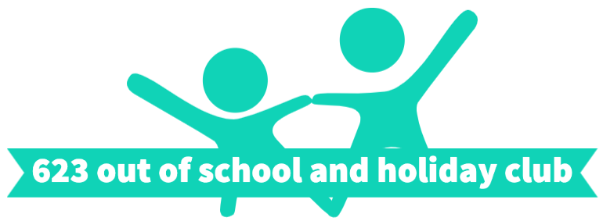

 | Book/ film themed week
 | Tuesday 11th August  Matilda and Charlie And The Chocolate Factory | Wednesday 12th August  Harry potter | Thursday 13th August  Disney
8:30-9  Arrival | Bookmarks | Colouring and wordsearches | Colouring
 | Desgin and make own chocolate bar wrapping | Wands | Car craft
10:30am
Snack Break
On the MUGA | Miss Trunchbulls challenges | Devils snare escape | Queens heart croquet
 | Desgin and make own chocolate bar | Edible sorting hat | Mickey mouse cheese puffs
12:30pm
Lunch Break
 | Split pin newt | Broomsticks | Design your own mirror
On the MUGA | Obstacle course | Broomstick races | Disney bop it challenge
 | Design and make your own library bag | Dragon eggs | Slinky dog craft
3pm
Break
 | Roald Dahl science | Potions | Bracelets
 | Library book memory game | Owl craft | Design your own forky

