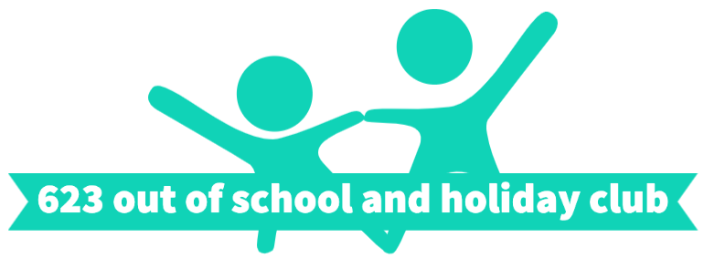

 | Seaside theme
 | Tuesday 4th August | Wednesday 5th August | Thursday 6th August
8:30-9am | Play/ Summer colouring | Play/ | Play/
 | Building beach shelters | Making ice lollies | Make your own summer bunting
10:30am
Snack Break
On the Muga | Tennis | Hockey | Badminton
 | Windmills | Frisbee making | Seaside cupcakes
12:30pm
Lunch Break
 | Kite making | Sun hats | Paper cup light house
On the Muga | Swim fishy swim and volley ball | Parachute games | Magic carpet relay
 | Smoothies | Sand art pictures | Ocean slime
3pm
Break
 | Rainbow fish | Sandcastle pen pot | Octopus
 | Ice lolly craft | Loom bands | Postcards

